Activities carried out between

January 2008 and December 2008

A – Services and activities provided by MCDA at the Pilot Center
- Awareness / Social services to the community – every week parents approach the center seeking information about LD and developmental disorders.
- Parent support – this support has been given to 15 families in order to advise parents as well as to clarify their doubts about their children.
- Services referrals – MCDA refers children to other institutions for evaluation or therapeutic services, that our association can not provide.
- Services Subsidy – MCDA subsidize therapeutic and special educational support services for children with Autism and LD.
- Integration Learning Through Play Activities – these group activities have been developed for children from 2 to 12 years of age, with the objective of integrate children with autism and learning difficulties, to train and offer them therapy in an environment of socialization and to promote the love to learn. Throughout 2008, 109 children attended these activities. These learning through play activities developed in 2 hours sessions include:
- Drawing and painting – activities that strengthens motor skills and can also be a way of learning shapes, contrasts, boundaries, spatial awareness, and other math concepts/ideas;
- Music – through music children learn about rhythm, sound and pitch and academic facts (like the alphabet song or multiplication table). Music can help the children to learn easier and more fun and it also develops memory and recall skills.
- Dance – By dancing, children can learn sequencing rhythm and following directions, it also develops their personality by interacting with others because dancing is a way of socializing. While developing coordination and motor control, children can also learn counting and directionality which are basic skills to enhance reading and writing concepts – such as understanding the difference between similar looking letters (like p/b/d/q) and discriminate left from right.
- Performing plays – is an opportunity for children to “put themselves into one’s shoes” through acting according to the given themes and learn about it in a profound and personal way.
- Arts & Crafts – reinforce children’s self-expression. Children can develop vital problem solving skills without having to rely on areas of expression that maybe more challenging. It leads to self-discovery, develops positive attitudes (such as patience, perseverance, giving and sharing).
- Science projects – by performing chemical experiences and making gadgets children can observe and learn about science facts in a fun way.
- Summer activities During the summer period, from June to September, 50 children attended the daily activities. Organized in different age groups of 8 children, the morning time activities had 16 children and the afternoon time activities 50 children (Table 1 & 2, following page);
- Toddlers & Weekend Integration Play Groups – From September to the present a total of 30 children between 2 and 9 years of age attend these integration group activities. (Table 2 & 3, following page).

List of activities and the number of children
Date | Activity | Information | Number of Participants
2008 May to Sept | Integration Learning through Play Summer Activities | Children from 2 – 11 years old | 55 children
2008 Sept to Dec | Integration Learning Through Play Activities | Toddlers (from 2 – 4 years old) | 18 children
2008 Sept to Dec | Integration Learning Through Play Activities | Weekend (from 4 – 9 years old) | 12 children
2009 January | Integration Learning through Play Activities | Toddlers (from 2 – 4 years old) | 17children
2009 January | Integration Learning through Play Activities | Weekend (from 4 – 8 years old) | 12 children
Total of children |  |  | 134children
Waiting List 30 children

Toddlers Integration Playgroup
2008 Balance Record
Expenses
Staff | Qt | Hours/Session | N°of Sessions/Month | MOP/Hour | Cost/session | Monthly cost | Yearly
Full Time | 2 | 4 | 12 | $78.00 | $624.00 | $7,488.00 | $89,856.00
Full Time | 1 | 4 | 12 | $30.00 | $120.00 | $1,440.00 | $17,280.00
Part Time | 4 | 3 | 12 | $30.00 | $360.00 | $4,320.00 | $51,840.00
Part Time | 1 | 3 | 12 | $20.00 | $60.00 | $720.00 | $8,640.00
Office | 1 | 1 | 12 | $30.00 | $30.00 | $360.00 | $4,320.00
Sub Total 1 |  |  |  |  | $ 1,194.00 | $ 14,328.00 | $171,936.00
Materials
Arts & | - | - | 12 | - | $150.00 | $1,800.00 | $21,600.00
Educational | - | -
Food & | - | - | 12 | - | $100.00 | $1,200.00 | $14,400.00
Beverage | - | -
Stationary | - | - | 12 | - | $100.00 | $1,200.00 | $14,400.00
Sub Total 2 |  |  |  |  | $350.00 | $4,200.00 | $50,400.00
Total of Expenses |  |  |  |  | $1,544.00 | $18,528.00 | $222,336.00
Income
 | N° of children | N°of integrated  children | N° of Sessions | Fee/Session | Total/Session | Monthly Total | Yearly
Full payment | 7 | - | 12 | $60.00 | $420.00 | $5,040.00 | $60,480.00
 | - | 1 | 12 | $60.00 | $60.00 | $720.00 | $8,640.00
Partial payment | 2 | - | 4 | $60.00 | $120.00 | $480.00 | $5,760.00
 | 3 | - | 18 | $60.00 | $180.00 | $3,240.00 | $38,880.00
 | 1 | - | 12 | $60.00 | $60.00 | $720.00 | $8,640.00
 | 1 | - | 3 | $60.00 | $60.00 | $180.00 | $2,160.00
MCDA children subsidy | - | 1 | 12 | $60.00 | $60.00 | $720.00 | $8,640.00
Total of Income |  |  |  |  | $900.00 | $10,380.00 | $124,560.00
MCDA Subsidy (Income - Expenses) |  |  |  |  | -$644.00 | -$8,148.00 | -$97,776.00

Weekend Integration Playgroup
2008 Balance Record
Expenses
Staff | Qt |  | Hours/Session | N°of Sessions/Month | MOP/Hour | Cost/session | Monthly cost |  | Yearly
Full Time | 1 |  | 4 | 4 | $78.00 | $312.00 | $1,248.00 |  | $14,976.00
Full Time | 1 |  | 3 | 4 | $30.00 | $90.00 | $360.00 |  | $4,320.00
Part Time | 4 |  | 3 | 4 | $30.00 | $360.00 | $1,440.00 |  | $17,280.00
Office | 1 |  | 1 | 4 | $30.00 | $30.00 | $120.00 |  | $1,440.00
Sub Total 1 |  |  |  |  |  | $792.00 | $3,168.00 |  | $38,016.00
Materials
Arts & | - |  | - | 4 | - | $75.00 | $300.00 |  | $3,600.00
Educational | - |  | -
Food & | - |  | - | 4 | - | $75.00 | $300.00 |  | $3,600.00
Beverage | - |  | -
Stationary | - |  | - | 4 | - | $50.00 | $200.00 |  | $2,400.00
Sub Total 2 |  |  |  |  |  | $200.00 | $800.00 |  | $9,600.00
Total of Expenses |  |  |  |  |  | $992.00 | $3,968.00 |  | $47,616.00
Income
 |  | N° of children | N°of integrated  children | N° of Sessions | Fee/Session | Total/Session | Monthly Total | Yearly
Full payment |  | 6 | - | 4 | $60.00 | $360.00 | $1,440.00 | $17,280.00
 |  | - | 1 | 4 | $60.00 | $60.00 | $240.00 | $2,880.00
Partial payment |  | 5 | - | 3 | $60.00 | $300.00 | $900.00 | $10,800.00
Total of Income |  |  |  |  |  | $720.00 | $2,580.00 | $30,960.00
MCDA Subsidy (Income - Expenses) |  |  |  |  |  | -$272.00 | -$1,388.00 | -$16,656.00

Integration Learning Through Play Activities
Summer Activities – June to September 2008
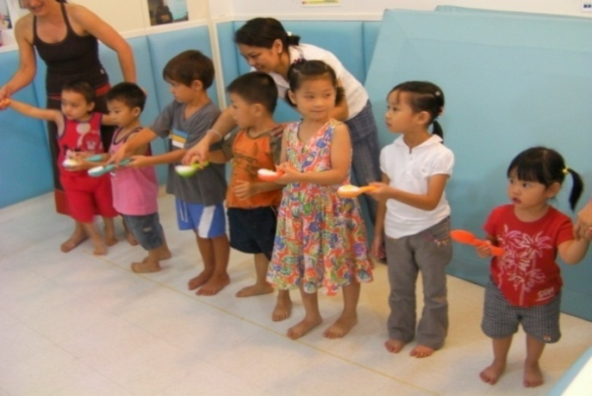
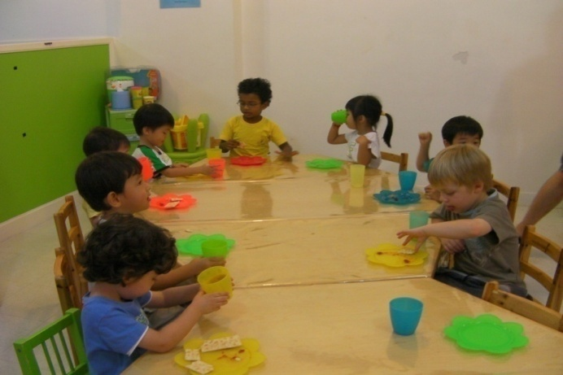

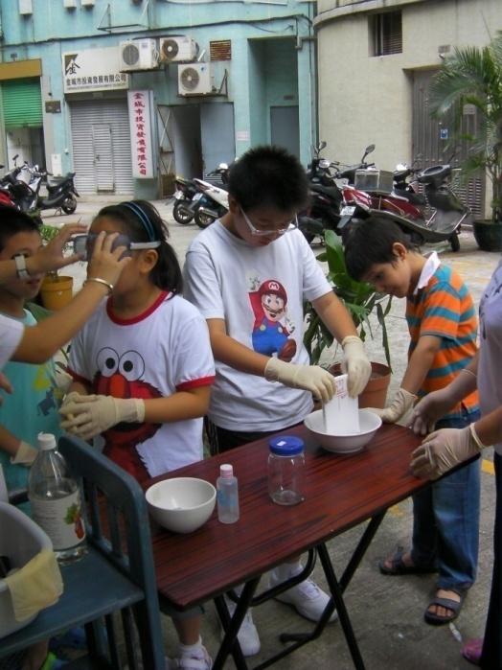

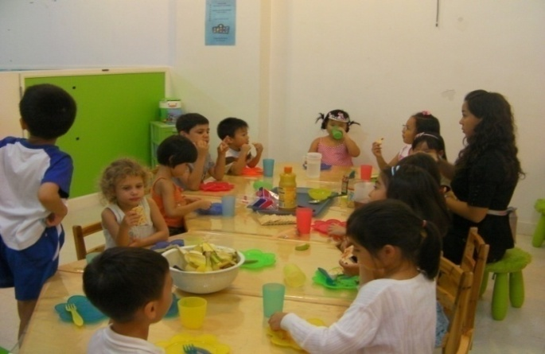

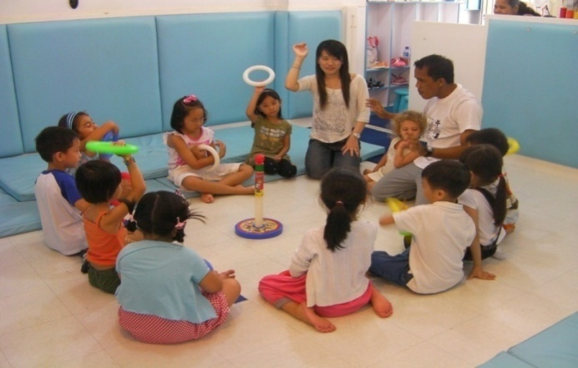
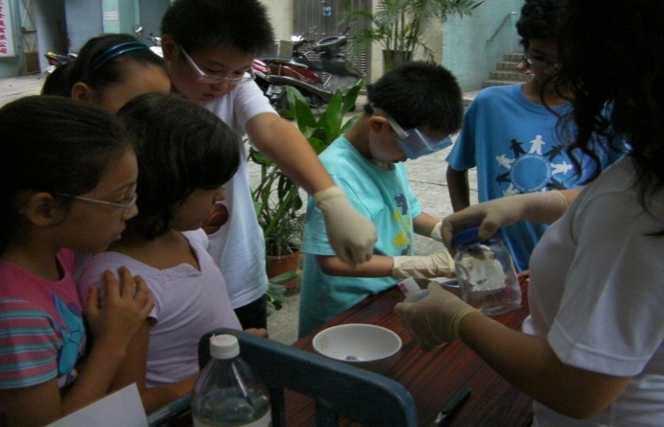

Integration Learning Through Play Activities
Toddlers & Weekend Integration Play Groups
September to present
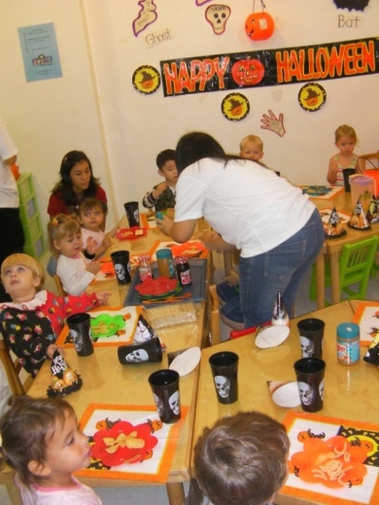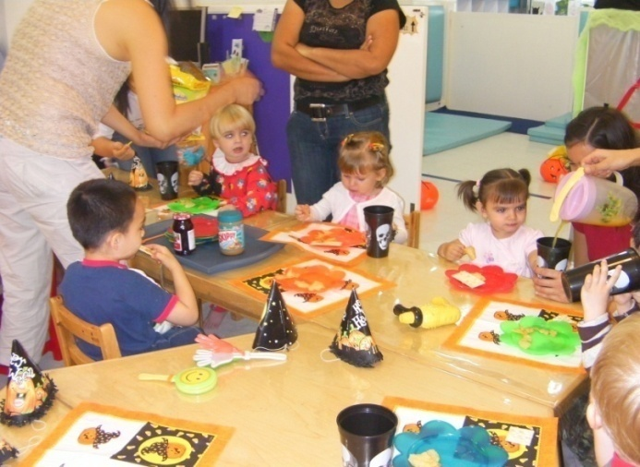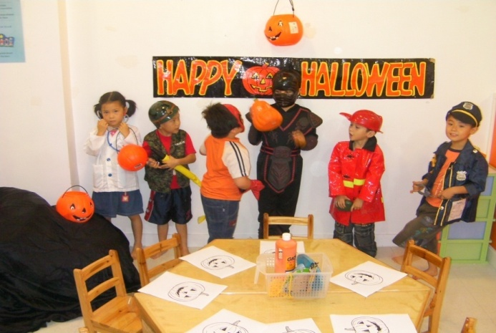

- Home services for children with developmental difficulties – the therapist has accompanied children at home setting to help them to achieve the activities and to follow a routine, as well as, to prepare note records and progress reports to facilitate the parents or caregivers, the steps that are needed to follow to reach the settled goals. 4 children have been supported at the home setting;
- Internships for college students 3 and 4 year – During 2008 MCDA integrated, in the scope of curricular internships, students from the University of Macao, the Polytechnic Institute and the Macau Inter-University Institute, to support MCDA in its activities, such as: (therapy sessions, integration learning through play group activities, awareness campaigns about autism and learning difficulties and informing the community about the Association’s services)
- Evaluation of psychomotor disorders – during 2008, 38 families approached MCDA with concerns about their children development or difficulties in school. 8 children were formal assessed to screen possible delays or disorders in their psychomotor development.
- Job placements for Macau residents – In order to cover the needs of the increasing number of local families who approached MCDA looking for support, we hired more Macau residents for our staff team
- Therapeutic and Educational services for children with Autism and LD – During 2008 MCDA provided these services to 15 children and due to the families economic difficulties, for 4 children this support is provided for free and, for other 4 MCDA subsidize 50% of the costs. The services are listed below:
- 1:1 therapy – 6 children were and are supported in individualized therapy sessions two (2) or three (3) times a week;
- Small group therapy – a total of 9 children in three different groups attended the small group therapy 1 (one), two (2) or three (3) times a week;
- Special educational support for children with Autism – Creation of activities adapted to the children’s individual needs;
- Psychology students’ internship – the students have direct training from the therapist to assist the children to follow the activities during the therapy sessions;

Therapy Fees Income Record
1:1 Therapy
 | N° of children | N° of Sessions/week | MOP/Sessions | Monthly Total
Full Payment | 4 | 2 | $300.00 | $9,600.00
Partial Payment | 1 | 2 | $75.00 | $600.00
No Payment | 1 | 1 | $0.00 | $0.00
Sub Total 1 | 6 | 11 |  | $10,200.00
Group Therapy
 | N° of children | N° of Sessions/week | MOP/Sessions | Monthly Total
Full Payment | 2 | 3 | $150.00 | $900.00
Full Payment | 1 | 1 | $150.00 | $150.00
Partial Payment | 2 | 3 | $50.00 | $300.00
No Payment | 4 | 1 | $0.00 | $0.00
Sub Total 1 | 9 | 8 |  | $1,350.00
Total |  |  |  | 11,550.00

- Workshops – organized workshop to raise the community awareness about the difficulties of learning and training for educators (parents, teachers) of children with difficulties - "Screening of learning difficulties in pre-school" – the location: Kindergarten D. José da Costa Nunes, April 2008.
- Synergies – MCDA has established synergies with other institutions (ILCM – Moms & Tots) and individuals that used the pilot center to carryout out supplementary activities related to children – 8 families benefit from these services;
- MCDA meetings - MCDA Board of Directors and General Assembly meetings are held at Taipa pilot center;

B – Services and activities outside MCDA Center
- Awareness and information dissemination – in the last year MCDA developed these campaigns through the media and participating in the following public events:
- Attendance at the annual event in celebration of the Lawyer’s Day of held at Senado Square on 23rd, 24th and 25th of May 2008
- 1st International Forum for Autism & Learning Difficulties – Organized by MCDA held at Macau Polytechnic Institute (IPM) on 18th and 19th of December
- MCDA 2008 Charity Christmas Dinner – celebrating the closing of the 1st International Forum for Autism & Learning Difficulties and the Macau SAR establishment day

Commemoration of the Lawyer’s Day
Senado Square - May 2008
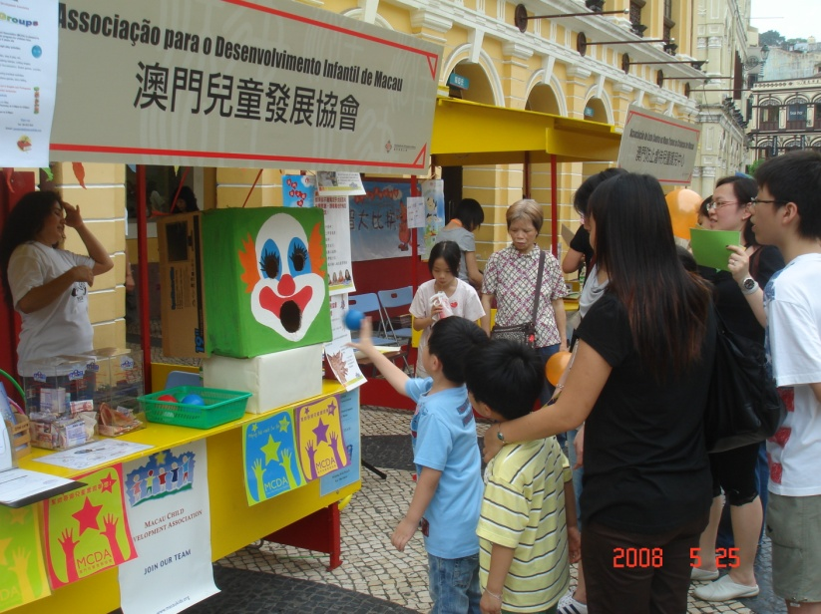
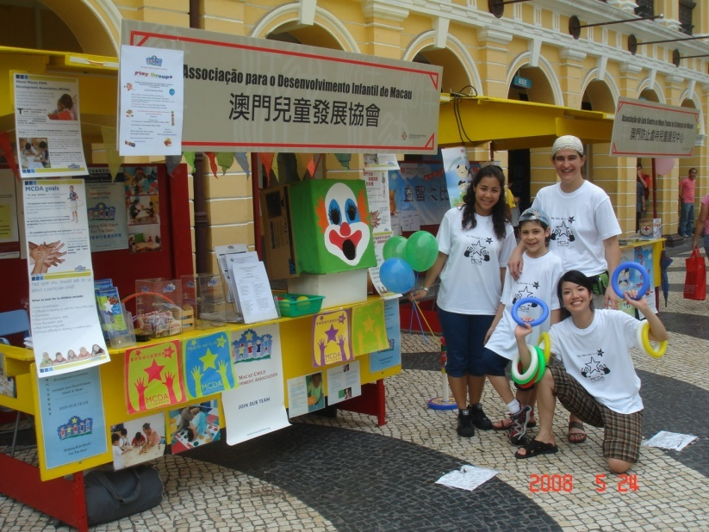

1st International Forum for Autism
&
Learning Difficulties
Macau Polytechnic Institute
18th & 19th of December
MCDA is very pleased to inform that the 2 days forum for autism, and learning difficulties held at IPM in December was a great success, even though it was on working days.
Dates & Venue
December 18th – 19th, 2008 at the Macau Polytechnic Institute
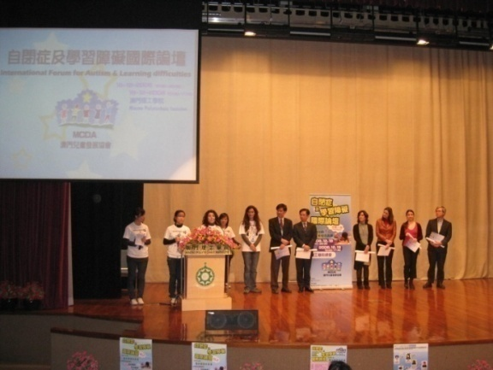
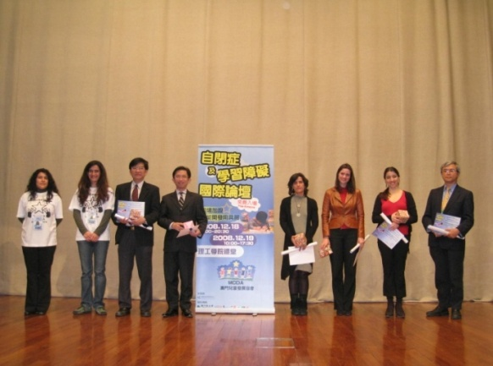
Number of participants
317 people during the 2-day conference.
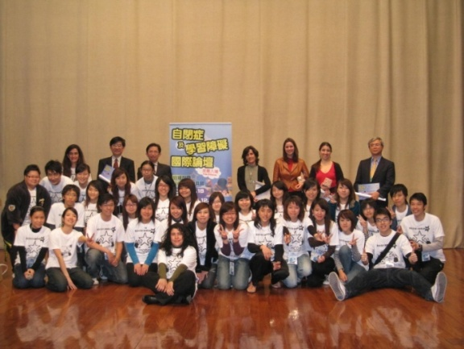
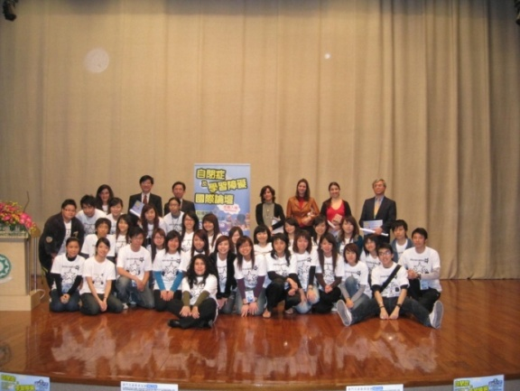
CADin Development Center
CADin Development Center, which provides similar services in Portugal, is a potential synergy with MCDA. We are presently discussing with the center’s director, Mr. Nuno Lobo Antunes a long term relation. The representatives from this center, who were also speakers at our forum, indicated potential cooperation including exchange in training staffs and other ways to benefit both organizations. Multicultural exchange and statistic collection will also be the advantages of the cooperation.
Macau Delegation of Foundation Orient
Representatives of the Macau Delegation of the Foundation Orient indicated that the Foundation was prepared to offer limited financial support to MCDA for the creation of the educational therapy training classrooms. This financial support will not be sufficient to cover all of MCDA’s operating costs, so it is critical that other sources of financial support be identified very soon. We hope that there will be more institutions to join this support to make these services a reality.
Other Cooperation
Furthermore, MCDA also gets supports from other institutions or individuals. We will have cooperation with Kiang Wu Hospital and the University of Hong Kong in the near future as well as we have some lawyers, who are willing to give us counsel service.
Audience Feedback
There was active and positive feedback from the conference participants, including:
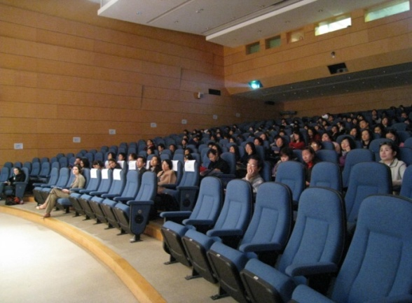
- Parents and other participants indicated they were glad to have attended the forum, which give them the opportunity to learn more about Autism and Learning Difficulties and, at the same time, enrich their knowledge about the situation of Autism and Learning Difficulties in Asia, especially in Macau, and now they know how to reach out to MCDA for other potential resources and help.

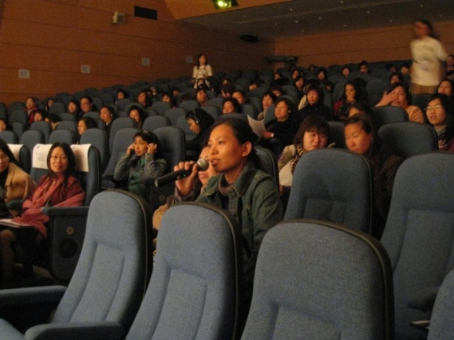
- The Q&A sessions after the presentations was very active and include questions as follow:

- How do I know if my child has Autism or not?
- What can I do to help my child?

Outcome
- The 1st International Forum for Autism and Learning Difficulties has given the opportunity for:
- A future investigation about Autism to be organized in collaboration with the University of Hong Kong;
- Conduct statistics researches related to Autism in Macau;
- Have access to the presented educational materials to the Macau community.
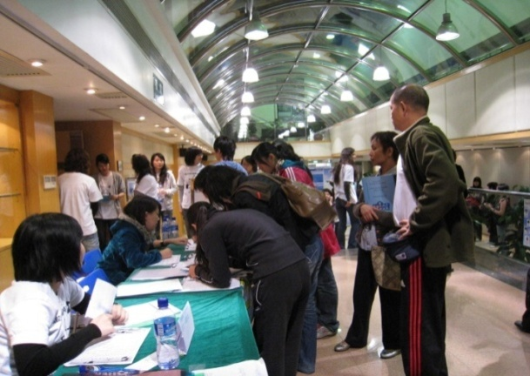
- The high participation in the Q&A session showed that parents had a great interest on the subjects and concern regarding their children.
- Other Macau organizations attending the conference are considering organizing Summer camp activities alongside MCDA, and are interested in participating with MCDA in the Summer camp for children with LD and Autism.
Closing Banquet
Macau Tower – 19th December
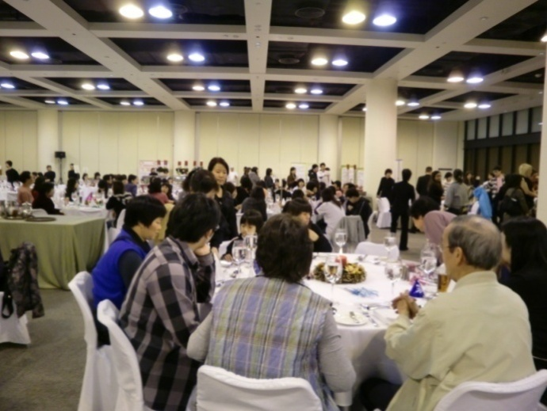
On the last evening, a banquet at the Macau Tower was organized. 280 people attended the banquet, including more than 40 children. The kids enjoyed the performance, especially the performance by the magicians. MCDA also provided entertainment for the children by setting up a playing area.
- There were several performances on that night, two singers from Hong Kong. Dancing, performed by children.
- We also arranged several games on that night, such as, wrapping presents, etc.

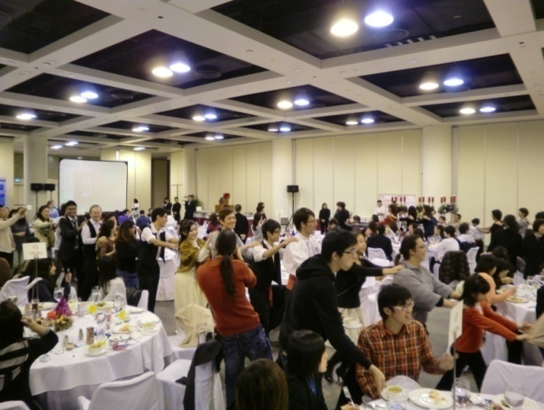

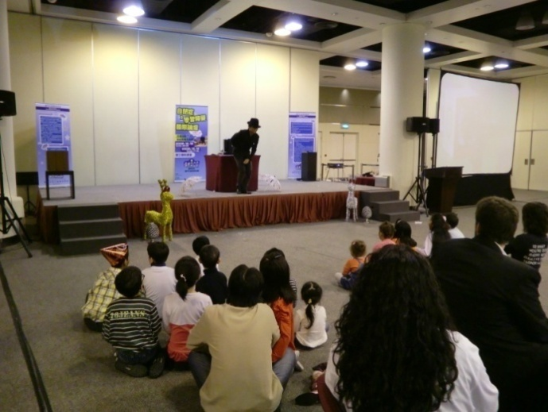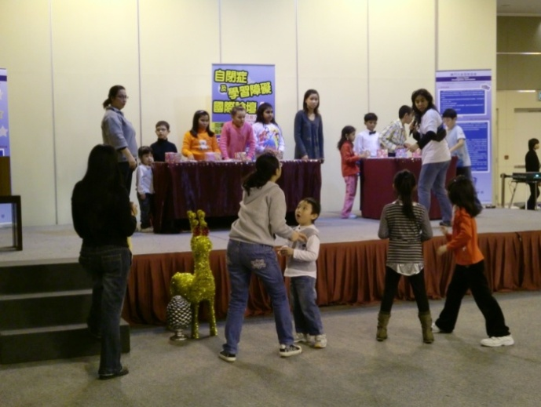

Conclusions
In spite of the critical financial situation and the limited staff, throughout 2008 MCDA was able to:
- Offer 25 working places, in part-time basis, to students from the University of Macao, the Polytechnic Institute and the Macau Inter-University Institute.
- Organize several marketing activities, such as: school visits, interviews for the Macau media, participation in public events.
- Organize the 1st International Forum for Autism and Learning Difficulties and the Banquet. For the two events MCDA had hired 44 students from different universities of Macau.

